Assignment 6

Name – Abhishek Agrahari

Roll Number 190123066

Question 1

IM = , where $Y_{i}=ⅇ^{\sqrt{U_{i}}}$

$s_{n}^{2}=\frac{1}{n-1}\sum_{i=1}^{n}{{\left(Y_{i}-{\hat{μ}}_{n}\right)}^{2}}$

Formula of L and U for 95% confidence interval are-

L = ${\hat{μ}}_{n}-1.96\frac{s_{n}}{\sqrt{n}}$, where n = M and sn as defined above.

R = ${\hat{μ}}_{n}+1.96\frac{s_{n}}{\sqrt{n}}$

For different values of M, IM, L and R obtained from the generated sample are as below –

i) M = 100, IM = 1.9996175037246708, L = 1.9024585893986745 and

U = 2.096776418050667

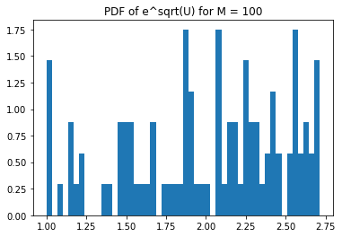

ii) M = 1000, IM = 1.9932103785476072, L = 1.96512374455047 and

U = 2.0212970125447445

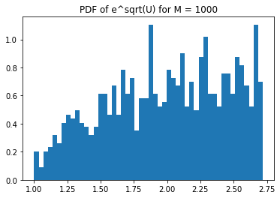

iii) M = 10000, IM = 2.0064320742351125, L = 1.9977475884040865 and

U = 2.0151165600661387

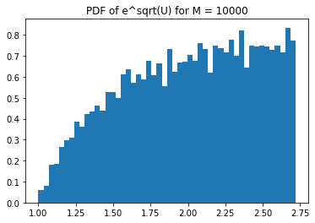

iv) M = 100000, IM = 2.0029214438351355, L = 2.0001837087749217 and

U = 2.0056591788953493

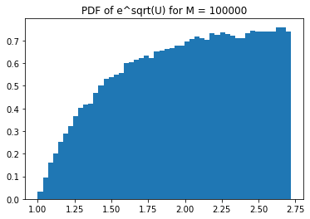

Exact value of I = $\int_{0}^{1}{ⅇ^{\sqrt{x}}ⅆx}=2$

As the value of M increases, IM gets closer to I which is 2 and the confidence interval also shrinks. Graph become much smoother and take the shape of original PDF with increase in M.